SPEEDTEST MODULE

CONTENTS

This module has the following files:
- MODULE_SPEEDTEST.doc
- MODULE_SPEEDTEST_MEDIA.zip

A1. Messenger
Draw 2 screen mockups for a messenger app with size 360x640.
1 screen - a list of dialogs (avatar, full name, message preview, new message button).
2 screen - chat with the user (avatar, full name, menu (three points), messages, text field, send button)
All elements should exist.

A2. Landing Page
Create a landing page consisting of navigation bar, logo, menu with dropdown, hero section with heading text, and call to action (CTA).

B1. Loading Animation
We want to create the following CSS loading animation.


B2. Digital Timer
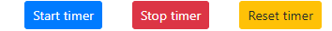
Create a digital timer, time format is: 3 digit of seconds passed, and centiseconds following it. It’s max value is: “999:59”. “Start timer“ button starts, “Stop timer” button stops, “Reset timer” button stops and resets to 0 the timer.
020:01

C1. Canvas Animation
Draw a circular figure in a container of 320px height and 400px width using canvas. When the browser window reloads, the circular object must move from left to right continuously.




C2. Transition
You are given a picture that you need to cut into N cards after “Split Image” button clicked, with dinamic input X and Y.
Each card should disappear animated when card is clicked.
Exampe X is 5 and Y is 3.
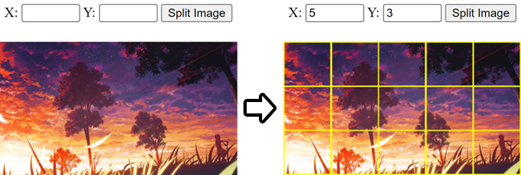

D1. PHP Calendar
1. You can create index.php using index.html
2. When you open the index.php, in the top area of calendar, current month and current year should be shown and today's date should be highlited like index.html
3. If you click the left arrow button the previous month calendar should be shown.
4. If you click the right arrow button the next month calendar should be shown.

D2. Watermark
Given an image and a logo (png file), the web should output an image with a watermark in the top right.

E1. XML2JSON Converter
Create a simple xml to json convertor using pure PHP(See the example.xml).
Screen shot:
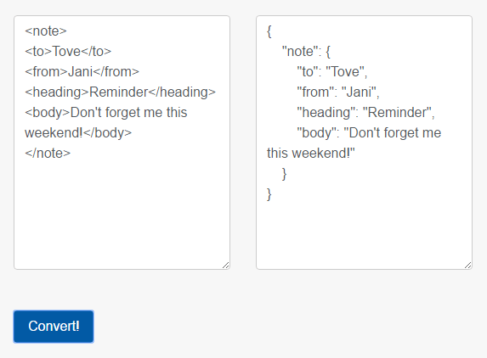

E2. Chat Analytics
Provided a JSON file of user messages, you need to make the analytics of the messages sent which is consist:
- Top 5 sent words
- Total messages sent
- Total messages received
- Average character length sent
- Average character length received
Example:


